Many members have asked what they can do to help with evacuation efforts and other forms of relief for those trying to flee Afghanistan.  We know that local resettlement agencies are resettling Afghans with ties to Minnesota (this is a limited number because there is not a large Afghan community in the Minnesota/Dakotas region).  We also know that, according to AILA National’s roundtable discussion, large groups of Afghan evacuees are being sent to Virginia, California, and Texas. Our pro bono committee is in regular contact with resettlement agencies. In the event the committee hears of plans for large groups of Afghans to come to Minnesota, we will most likely need pro bono assistance.

Below is a list of resources ExComm has compiled for your consideration:

**AILA National Afghan Resource Page**

* Please visit AILA’s [Afghan Resources page](https://www.aila.org/about/announcements/resources-assisting-afghan-clients), for the latest information, resources, and developments. While this page was designed for members, it is accessible to the public and can be shared with clients and the community who may need access to resources.  The page includes a link to a parole practice advisory from CLINIC that may be helpful:   <https://cliniclegal.org/resources/parole/all-about-parole-practice-advisory>. This page is continuously updated so please check it regularly.

**AILA’s Afghan Response Taskforce**

* AILA National has set up an Afghan Response Taskforce. The goal of the Taskforce is threefold:
  + ***Provide resources*** to AILA members who are assisting Afghan clients – this includes creating practice pointers and alerts,  sharing materials from other organizations, monitoring the Afghan Evacuations listserv and message center to provide feedback to members and identify problematic trends, and provide training, such as the AILA U Roundtable held last week and **the AILA U roundtable scheduled for August 25, 2021 at 1pm CT (Register here:** [**https://elearning.aila.org/p/AFGHAN-2**](https://elearning.aila.org/p/AFGHAN-2)**).** More info available on the[**Assisting Afghan Clients Resource Page**](https://www.aila.org/about/announcements/resources-assisting-afghan-clients)
  + ***Help make pro bono connections*** between AILA members and organizations assisting Afghans: ([Sign Up as Point of Contact with AILA](https://airtable.com/shrU198Ld6VP7uOl9) and [Help Afghans Find you Online](https://www.aila.org/about/announcements/help-afghans-find-you-online))
  + ***Administrative and Legislative Advocacy*** to ensure that Afghan clients are given proper relief and guidance for attaining such relief.For example, AILA sent this letter to USCIS on Friday **-** [AILA Requests Clarity from USCIS on Afghanistan Evacuation Policies](https://www.aila.org/advo-media/aila-correspondence/requests-uscis-on-afghanistan-evacuation-policies)

**Emergency Roundtables**

* AILA had over 650 attendees on its Roundtable discussion; a [free recording](https://elearning.aila.org/p/AFGHAN) is available for those who missed it. The next roundtable is scheduled for August 25, 2021 at 1:00 (CT). Information can be found at the Resources Page link above.

**AILA ListServ**

* AILA National has set up a listserv on Afghan evacuations that any AILA member can join. This would be the place to share real time, on-the-ground updates and resources, and a place to ask questions. You can join the listserv by going to My AILA to subscribe.  <https://www.aila.org/MyAila/Account/Listservs>

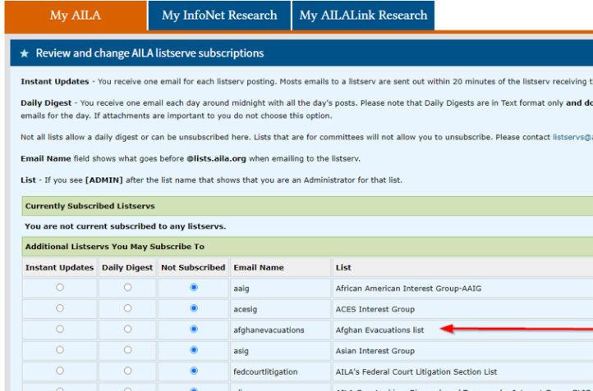

**AILA National Message Center**

* AILA has also set up an AILA Message Center Forum for Kabul/Afghanistan Evacuations, which you can find [here](https://messages.aila.org/forumdisplay.php?162-Kabul-Afghanistan-Evacuations).

**Pro Bono Assistance: Humanitarian Parole**

* Pars Equality Center (national).  Pars Equality Center is a non-profit organization located in California whose mission is to catalyze social, civic, and economic integration of immigrants from Persian-speaking and other countries into America. Pars has taken up the task of providing assistance with Humanitarian Parole filings for those trying to flee Afghanistan. They are overwhelmed and need all the help they can get. Specifically, they are looking for **volunteer attorneys who can provide legal assistance in English, Pashto, or Dari to help with the preparation of Humanitarian Parole requests, repatriation forms, and follow up with Congressional representatives.**  If interested, please email [afghansupport@parsequalitycenter.org](mailto:afghansupport@parsequalitycenter.org).

Incidentally, if you are receiving inquiries from Afghan individuals and you do not handle these cases, you can route them to fill out the company’s intake form found at: <https://tinyurl.com/3T9VYRSH>.

* Volunteer Lawyers Network (VLN) (local). VLN’s Afghan Humanitarian Parole Legal Clinic serves as the clearinghouse for applicant/petitioners located in Minnesota who are seeking assistance in filing Humanitarian Parole Applications for Afghan nationals located outside the United States, as well as for attorneys in Minnesota wishing to assist them. VLN provides consults, pro se assistance, and full representation for the applicant/petition located in Minnesota for Humanitarian Parole cases. Attorneys who would like to volunteer to help provide services can also contact VLN.

Those seeking legal assistance can apply [here](https://vln.formstack.com/forms/vln_intake_ilsp_afghan_humanitarian_parole_clinic).

Attorneys who wish to volunteer can do so [here](https://vln.formstack.com/forms/vln_intake_ilsp_afghan_humanitarian_parole_clinic).

**Pro Bono Assistance: Legal Services for Afghan Nationals in the United States**

* Advocates for Human Rights (local). The Advocates for Human Rights is conducting legal clinics for Afghan nationals in Minnesota seeking assistance in applying for immigration benefits other than humanitarian parole (e.g., asylum, SIV, etc.). The Advocates is seeking attorneys to help with this project.

If you are an attorney willing to assist in providing legal representation to Afghan nationals in the United States seeking immigration benefits, please visit the Advocates’ pro bono representation page [here](https://www.theadvocatesforhumanrights.org/Volunteer/Represent?bbeml=tp-ONSbsiVVyEC7Xz22jO-szg.jkp9Z20V1-kiUQ5Qt8h69Kw.rP4geO2ESREy3XSFp-nCpmQ.lhX9eeh1XMk2DyCju6WIhDA).

**Pro Bono Assistance: Special Immigrant Visas (SIVs) and P-1 and P-2 Referrals to the U.S. Refugee Admissions Program**

* International Refugee Assistance Project (IRAP) (national). IRAP provides resources for assisting individuals in Afghanistan, including SIV and P-2 guides, as well as a guide for media and NGO employers in Afghanistan. It also provides opportunities for attorneys interested in volunteering in this area.

Click [here](https://refugeerights.org/news-resources/legal-resources-for-afghans) for information.

**Pro Bono Assistance: Military Bases**

* There is a significant need for legal volunteers to help our Afghan guests housed at military bases throughout the USA.  There are over 9 military bases housing over 50,000 Afghans as they wait for assignments to resettlement organizations.  Some have been on these bases since August. AILA is organizing volunteers at some of the bases, while some are organized by USCCB.  AILA member Chris Chaney is the Afghan TF Pro bono team lead and has been extraordinary in arranging the orientations.  We have pulled together materials to support those of you interested in volunteering and the TF prepared a video training providing some key information.  **USCCB is providing reimbursement for travel and lodging expenses.**

**Fort McKoy which is housing 13,000 Afghan guests.  Fort Bliss in TX is housing roughly 10,000, and Joint Base McGuire-Dix-Lakehurst has 9000 Afghans - each has significant need for immigration attorneys and paralegals.**

To sign up: <https://signup.com/client/invitation2/secure/856989671661656063/false#/invitation>

To sign up for Ft. Bliss: [volunteer@dmrs-ep.org](mailto:volunteer@dmrs-ep.org)

Training video: <https://elearning.aila.org/p/AFGHAN-3>

**Afghan Allies Application Review**

* If you are interested in helping US veterans and nonprofits seeking to assist Afghans fleeing Afghanistan on a pro bono basis, please sign up [here](https://airtable.com/shrU198Ld6VP7uOl9).  PLEASE NOTE that mentorship of SIV/P2 cases **is not** available at this time, so training is not provided.

**Where You Can Donate**

* International Institute of Minnesota (<https://iimn.org/afghanistan/>)
* Minnesota Council of Churches ([Minnesota Council of Churches (mnchurches.org)](http://www.mnchurches.org/what-we-do/refugee-services))
* Lutheran Social Service ([www.lssmn.org](http://www.lssmn.org))
* Arrive Ministries ([arriveministries.org](http://arriveministries.org))
* Catholic Charities, Rochester (<https://www.cccsrochester.org>)
* International Refugee Assistance Project (<https://refugeerights.org/>)

**SIV Cohort Assistant Employment Opportunity**

* The International Rescue Committee (IRC) has full-time positions available for those interested in service as Special Immigrant Visa (SIV) cohort assistants. The closest opportunities are in Madison, Wisconsin and La Crosse, Wisconsin. The IRC is looking for a minimum commitment of 14 consecutive days, with preference given to those who can make longer commitments). For more information visit <https://rescue.csod.com/ux/ats/careersite/1/home/requisition/19549?c=rescue>.

**Cornell University Afghanistan Assistance Resource List**

* Stephen Yale-Loehr has been working with his immigration law students at Cornell University to compile a resource list for Afghans at risk. The list includes links to many organizations that are providing assistance and resources for relief for Afghans. The list can be found at <https://docs.google.com/document/d/14aHqVbqO2ivtqA8Wl05Lvb0IfaCR1TkN8CDPqLDjuEc/edit>.

**CLINIC Assistance for Afghanistan Toolkit**

* CLINIC has developed an online “Assistance for Afghans Toolkit” at <https://cliniclegal.org/toolkits/assistance-afghans>. The toolkit contains links to and contact information for the DOS Afghanistan Coordination Task Force (ACTF),  Repatriation Assistance Request Form, congressional contacts, the DOS and DHS, a sample cover letter and template for humanitarian parole, and other resources.